# Semester Project Phase 2: Problem Analysis SDU Sønderborg 2023 Semester 1

**Mubashrah Saddiqa** [**msad@mmmi.sdu.dk**](mailto:msad@mmmi.sdu.dk)

Sep 6, 2023

# Purpose and Objectives

The purpose of the problem analysis phase is to establish the foundation for the group's project. By the end of this phase, the project group will have achieved the following objectives:

* Completed the problem analysis.
* Made method selections.
* Developed an overall project plan.

Subsequently, the project group will have created and obtained approval for the project foundation.

# Tasks in this Phase

**Problem Analysis**

The problem analysis involves comprehending the project's starting point and identifying the problem that aligns with the project and is of mutual interest to the project group. The problem analysis also includes an examination of the solution framework, known as the "World of Zuul," established for the project.

**Method Selection and Overall Project Plan**

Method selection is pivotal to the project's progress because it defines how the project's problem will be addressed. The overall project plan will be developed as a time and activity schedule for the key activities within the project work.

**Project Foundation**

The project foundation is prepared both as preliminary chapters in the final project report and as a poster. Only the poster is submitted in this phase.

The preliminary chapters that need to be prepared are as follows:

* **Title Page**
* **Introduction**
* **Problem Statement**
* **Scope and Limitations**
* **Definitions of Concepts, Theory, and Academic Literature**

The poster will present the key points from the project foundation. The poster will be created using the Project Foundation (Poster) template (please see page 4). It should be in A0 format. See Figure 1 for specific details.

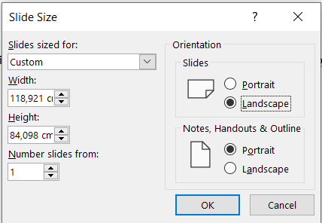

Figure 1: Slid size

The poster will be presented at a project seminar. The poster will be updated and submitted after the project seminar. We recommend that you will print the updated poster and will display it at your project workspace.

**Activities in Phase 02**

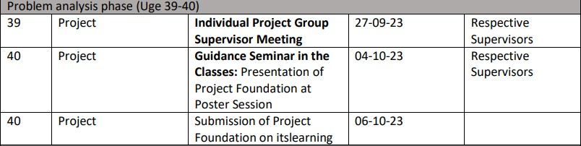

**Materials**

Materials1 that are particularly important in the problem analysis phase:

* Semester schedule
* Project description
* World of Zuul
  + Zuul framework (source code) [See Plans (02 Problem Analysis Phase)]
  + Ideas for exploring World of Zuul
* Project foundation (poster)

1 You can find the material on Itslearning under “

General Course Information”, “Semester Project and Project Description”, “Project start- Phase 1” and “02 Problem Analysis Phase”.

# Appendix 1: Exploration of the Provided Source Code in the Problem Analysis

During the project's initial phase, you will explore the provided source code as part of the problem analysis. We recommend that you complete the following tasks at a minimum:

1. **Execute!**

Create a new class called "Start," within which you include a main () method. Inside the main () method, create a reference to "Game," instantiate the class, and execute the play () method on the Game object you've created. Try running the program. What happens?

1. **Use the source, Luke!**

Being able to read source code is an essential skill in programming. Initially, you should read through the source code. Do this by opening the various classes and attempting to understand what they do. You may not grasp the entire source code right away, but as the semester progresses, it should become clearer. Use comments to describe the functionality on individual lines and for individual methods.

1. **Cause and Effect**

Make small changes in the existing code. Suggestions for changes you can make include:

* Change the name of a room.
* Modify the exits – for example, take a room that is currently west of another room and move it to the north.
* Add a room... and maybe more!

Ensure that you run the game after each change to ensure that it still functions. The above exercises will help you become familiar with the source code.

**Appendix 2: Presentation - Project Foundation - Poster**

